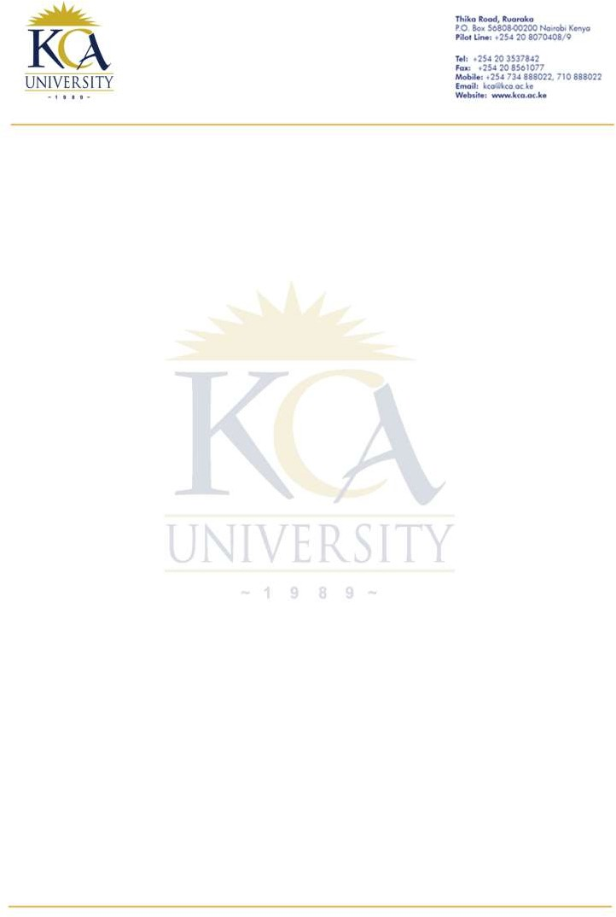
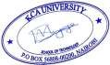

SCHOOL OF TECHNOLOGY

KCA/SOT/ JULY 25 Year 2025

TO WHOM IT MAY CONCERN

Dear Sir/Madam,

RE: MUTUA ROY NGURE REG. NO. 23/05917
I am pleased to recommend Mutua Roy Ngure, a dedicated and disciplined individual who attended KCA University while pursuing a Bachelor of Science in Information Technology.
During his time at the university, Roy consistently demonstrated strong technical skills, a collaborative spirit and excellent interpersonal qualities. He is respectful, responsible and approaches tasks with focus and a willingness to learn. He is highly adaptable and dependable making him well-suited for dynamic work environments. He has shown a strong desire to grow professionally and continuously improve his skill set.
I am confident that he will be a valuable asset to any organization and strongly recommend him for employment.
Yours faithfully,

Dr. Simon Mwendia
Dean, School of Technology

